
Business / Technical Brief

PEOPLESOFT TO UNIFIER – APPROVED INVOICES
INTEGRATIONS DESIGN SPECIFICATION DOCUMENT
Prepared For: Northwestern Memorial Healthcare

  - Author: Anu Samantha
June 2025, Version 1.0
Copyright © 2025, Oracle and/or its affiliates
Confidential – Oracle Restricted
Document Control

Change Record
Date | Author | Version | Change Reference
06/24/2025 | Anu Samantha | 1.0 | Initial Draft

Reviewers
Full Name | Title
Farkas-Loewes, Monika | NM Business
VanZale, Steve | NM IT
Agrawal, Amit | NM IT
Singh, Vishnu Devanand | NM IT

Approvals:
Approver 1 | Farkas-Loewes, Monika
Approver 2 | Cloutier, Charlie

Table of Contents
1 Introduction 5
1.1 Purposes 5
1.2 Audience 5
1.3 References 5
2 Integrations Overview 6
3 Interface Design 7
3.1 I8080- PeopleSoft Approved Invoices to Unifier Invoices 7
3.1.1 Properties of the Data Flow 7
3.1.2 Business Rules 8
3.1.3 Process Flow 9
3.1.4 Data Mapping 10
3.1.5 PIF Configuration 10
3.1.6 Error/Warning Handling 10
3.2 I8101- PeopleSoft Approved Change Order Invoices to Unifier Payment Application Invoices 11
3.2.1 Properties of the Data Flow 11
3.2.2 Business Rules 11
3.2.3 Process Flow 12
3.2.4 Data Mapping 12
3.2.5 PIF Configuration 13
3.2.6 Error/Warning Handling 13
4 Assumptions 14
5 Appendix A: Acronyms 15
6 Appendix B: Issue Log 16

Table of Figures
Figure 1: Interface Details 6
Figure 2: High Level Interface Diagram 6
Figure 3: I8080 – PeopleSoft Approved Invoices to Unifier Invoices 7
Figure 3: I8101 – PeopleSoft Approved Change Order Invoices to Unifier Payment Application Invoices 11
Figure 36: Acronyms 15
Figure 37: Issue Log 16

Introduction
Integration is the process of moving data from one data source to another on a recurring basis. The intention is to keep the target data source synchronized with relevant data from another data source. One is typically the “system-of-record”. The integrations for Northwestern Memorial Healthcare will be developed and configured using Oracle Project Integration Framework (PIF) referred as PIF henceforth on this document.

Purposes
The purpose of this document is the following:
- Document Oracle’s technical design and process flow for the interface
- As a deliverable, allow Northwestern Memorial Healthcare to approve and sign-off on the technical design.
- Document and maintain changes to the design over time.
- Provide future administrators and developers technical documentation to support the interface.

Audience
This document is intended for the following audiences:
- Technical resources supporting infrastructure.
- Application administrators and developers
- Northwestern Memorial Healthcare and Oracle Project Managers
- Solution Architects
- Business

References
This design specification refers the following information sources:
- Meetings and discussions with Northwestern Memorial Healthcare and Oracle teams.
- Field mapping identified by Northwestern Memorial Healthcare and Oracle teams.
- Future Process model
- Oracle’s Solution Design documents

Integrations Overview
This document covers the design details for transferring financial data from PeopleSoft to Primavera Unifier using PIF. PIF leverages web services to interface with PeopleSoft and Primavera Unifier.
The interfaces will be scheduled to run within PIF, and it also provides transaction log to view status of the integration jobs and email notifications for reporting transaction details and failures.
The below table details interface that will be implemented within the scope of integrations from PeopleSoft to Unifier. The term “Inbound” and “Outbound” is with the context to Primavera Unifier.

ID | Interface Name | Interface  Type | Source  System | Target  System
I8080 | I8080 - PeopleSoft Approved Invoices to Unifier Invoices | Inbound | PeopleSoft | Unifier
I8101 | PeopleSoft Approved Change Order Invoices to Unifier Payment Application Invoices | Inbound | PeopleSoft | Unifier
Figure 1: Interface Details

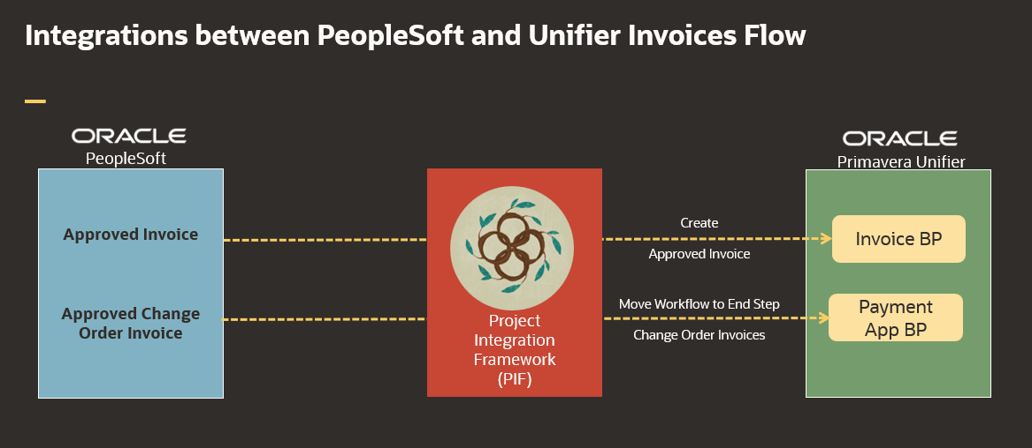
Figure 2: High Level Interface Diagram

Interface Design

I8080- PeopleSoft Approved Invoices to Unifier Invoices (PO)
This interface is used to create Invoices from PeopleSoft View to Invoice BP records in Unifier. Invoices will be updated at header level . Integration will move the workflow to End Step after updating Invoices header details.

Properties of the Data Flow
Interface ID | I8080
Interface Name | I8080 - PeopleSoft Approved Invoices to Unifier Invoices
Source System Name | PeopleSoft
Source System Object Name(s) | NM_UA_INV_023
Target System Name | Unifier
Target System Object Name(s) | Invoice BP
Interface Type | Inbound
Interface Frequency | Nightly- Once
Approximate # of Rows | 400 Invoices Per Day
Interface Mechanism | Unifier –Invoice BP  PeopleSoft – Views
Table Name Prefix | I8080
Figure 3: I8080 – PeopleSoft Approved Invoices to Unifier Invoices

Business Rules
Rule # | Rule Name | Rule Description
R-01 | Selection Criteria | Read Posted Invoices from PeopleSoft based on Invoice Date
R-02 | Invoice Status | Invoices status should be "Posted"
R-03 | Invoice Number and Voucher ID | Voucher ID and Accounting DT will be Unique
R-04 | PO Number | PO Number should be associated with Invoice.
R-05 | Invoice Creation | All Invoices will be created Under project
R-06 | Activity Codes | SetID Activity Type Description  SHARE 01000 Capital  SHARE 02000 Expense  SHARE 03000 Initiative
R-07 | Cost Codes | Cost Code (Source Type in PeopleSoft) Description  1100 Capital: Architect/Engineer  1200 Capital: Construction Manager  1300 Capital: Consultants  1400 Capital: Regulatory Agency Cst  2000 Capital: Construction  3000 Capital: Insurance  7000 Capital: Capital Contingency  7100 Capital: Capital Tenant Impr  8100 Capital: Medical Equipment  8200 Capital: Furniture/Support Equ  8300 Capital: Technology  9000 Operating Expense
R-08 | Line Items/Summary Level | Only Line Items should be brought in for Source Types - 1100, 2000 only. Rest all Source Types should be at header level or Summary level only
R-09 | Resource Type | Fetch transactions with Resource_type = ACT from PeopleSoft
R-10 | Source ID | SOURCE_ID = 'NM_UA_INV_023’

Process Flow
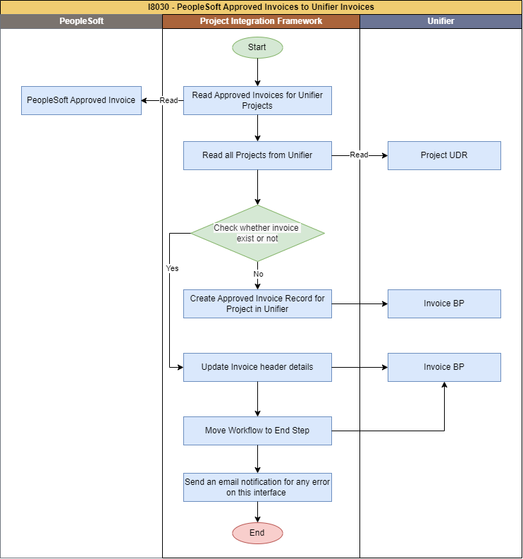
Figure 3: I8080 - PeopleSoft Approved Invoices to Unifier Invoices

- Clear data in PIF tables (if any) from last interface run.
- PIF to extract Approved Invoice data for all Projects from PeopleSoft based on PIF last Run Date.
- PIF will create approved Invoice BP records in Unifier with the Integration Status column set to "New" in PIF staging Table
- PIF to update Invoice header detail(s) to sync data with recent changes made to PeopleSoft Invoices. This update includes changes to header details.
- PIF to move the Invoice workflow to End Step after updating header details.
- PIF will update the field " Integration Status " in the Unifier Approved Invoices BP, setting it to "Sent from PeopleSoft”.
- PIF will generate email error notifications if there is any error while inserting data into Unifier.

Data Mapping
The below is the SharePoint link for data mapping for this interface.
Oracle-NM-PeopleSoft-Unifier-Invoices-Integration-Mapping.xlsx (Invoice Tab)

PIF Configuration
Interface Name: I8080 - PeopleSoft Approved Invoices to Unifier Invoices Data

To be filled/corrected after completion of interface development.

Step No/ Intent | Step information | Business Rules / Comments
Step #: 10  Step Name: Truncate PIF tables | Service Name: SQL Service  SQL Type: DELETE | Truncate all PIF tables, stage tables
Step #: 20  Step Name: Get Inflight Invoices from PeopleSoft | Service Name: SQL Service  SQL Type: SELECT  PeopleSoft View Name: NM_UA_INV_023  Table Name: I8080_PSFT_INV | Read Invoices from PeopleSoft
Step #: 30  Step Name: Skip the steps if there is no data from peoplesoft to process | Service Name: GoToService  Is Conditional: True  Go To Step Sequence: End Process (-1)  Table Name: I8080_PSFT_INV_ROWS | Check if there are any Invoices to process or not. If not Skip all the interface steps and move to end step.
Step #: 40  Step Name: Get Projects from Unifier | Service Name: UnifierRESTV2Service  Object Name: User Defined Report  Method Name: Get UDR  UDR Name: I8020_ProjectDetails  UDR Level: Project Shell  Table Name: I8080_UNI_PROJECTS | Get existing Projects from Unifier using UDR
Step #: 50  Step Name: Check Project Exists in Unifier | Service Name: SQL Service  SQL Type: Update  Table Name: I8080_PSFT_INV_ROWS | Check whether the given project exists in Unifier.
Step #: 60  Step Name: Get Purchase orders from Unifier | Service Name: UnifierRESTV2Service  Object Name: User Defined Report  Method Name: Get UDR  UDR Name: I8050_PO_REPORT  UDR Level: Company  Table Name: I8080_UNI_PO | Get existing Purchase Orders from Unifier using UDR
Step #: 70  Step Name: Update pif status if purchase order doesn't exists in unifier | Service Name: SQL Service  SQL Type: Update  Table Name: I8080_PSFT_INV_ROWS | Check whether the given Purchase Order already exists in Unifier.
Step #: 80  Step Name: Get SOV Line details | Service Name: UnifierRESTV2Service  Object Name: User Defined Report  Method Name: Get UDR  UDR Name: TEST_SOV_LINE  UDR Level: Company  Table Name: I8080_UNI_SOV | Get SOV Details from Unifier using UDR
Step #: 90  Step Name: Get Invoices from Unifier | Service Name: UnifierRESTV2Service  Object Name: User Defined Report  Method Name: Get UDR  UDR Name: I8080_UNI_INV_REPORT  UDR Level: Company  Table Name: I8080_UNI_INV | Get existing Invoices from Unifier using UDR
Step #: 100  Step Name: Update pif status if invoice already exists to update the invoice | Service Name: SQL Service  SQL Type: Update  Table Name: I8080_PSFT_INV_ROWS | Check whether the given Invoices already exists in Unifier.
Step #: 110  Step Name: Update the records for processing | Service Name: SQL Service  SQL Type: SELECT  Table Name: I8080_PSFT_INV_ROWS | Loop to process one record at a time.
Step #: 120  Step Name: Create Approved Invoice in Unifier | Service Name: UnifierRESTV2Service  Object Name: Business Process  Method Name: Create BP Record  Business Process Name: Invoice  Table Name: I8080_PSFT_INV_ROWS | Create new Approved Invoice Record in the Unifier using PIF Staging Table.
Step #: 130  Step Name: Update Actual record | Service Name: UnifierRESTV2Service  Object Name: Business Process  Method Name: Update BP Record  Business Process Name: Invoice  Table Name: I8080_PSFT_INV_ROWS | Update Invoice header details in the Unifier as per the PIF Staging Table.
Step #: 140  Step Name: Move workflow to end step | Service Name: UnifierRESTV2Service  Object Name: Business Process  Method Name: Update BP Record  Business Process Name: Invoice  Table Name: I8080_PSFT_INV_ROWS | Move all updated Invoices to End Step.
Step #: 150  Step Name: Go to update step if there are still records to process | Service Name: SQL Service  SQL Type: SELECT  Table Name: I8080_PSFT_INV_ROWS | Move to the loop step for processing the next record.
Step #: 160  Step Name: End Process, Skip to run "Notify Failures" when there are no failed records | Service Name: GoToService  Is Conditional: True  Go To Step Sequence: End Process (-1)  Table Name: I8080_PSFT_INV_ROWS | Check if there are any failed Invoices or not. If not Skip all the interface steps and move to end step.
Step #: 170  Step Name: Notify Invoice failures | Service Name: Email Service  Conditional Criteria: Attachment Has Records  Attachment File Name: Error Notification : I8080_Invoice  Table Name: I8080_PSFT_INV_ROWS | Send an attachment listing all rows which are failed

Error/Warning Handling
Error # | Rule Name | Rule Description
E-01 | Approved Invoice Record creation failed | Email will be sent to admin for any failure

I8101- PeopleSoft Approved Change Order Invoices to Unifier Payment Application Invoices
This interface is used to update Voucher ID on Pencil Draw step and move Workflow to end step when a change Order Invoice is approved from PeopleSoft View to Payment App BP records in Unifier.

Properties of the Data Flow
Interface ID | I8101
Interface Name | I8101 - PeopleSoft Approved Change Order Invoices to Unifier Payment Application Invoices
Source System Name | PeopleSoft
Source System Object Name(s) | TBD
Target System Name | Unifier
Target System Object Name(s) | Payment Application BP
Interface Type | Inbound
Interface Frequency | Nightly- Once
Approximate # of Rows | 50 invoices per day
Interface Mechanism | Unifier –Payment Application BP  PeopleSoft – Views
Table Name Prefix | I8101
Figure 3: I8101 – PeopleSoft Approved Change Order Invoices to Unifier Payment Application Invoices

Business Rules
Rule # | Rule Name | Rule Description
R-01 | Workflow End Step | Move Payment Application to End step based on Record Number
R-02 | Invoice Status | Invoices status should be "Posted"
R-03 | Unifier Project Number and Record Number | Unifier Project Number and Record Number will be Unique.
R-04 | Pencil Draw Step | Update Voucher ID and Accounting date from Peoplesoft to Unifier when the record is in Pencil Draw Step
R-05 | Final_Voucher_Build Status | Update header details from Peoplesoft to Unifier when the record is in Final_Voucher_Build status.

Process Flow
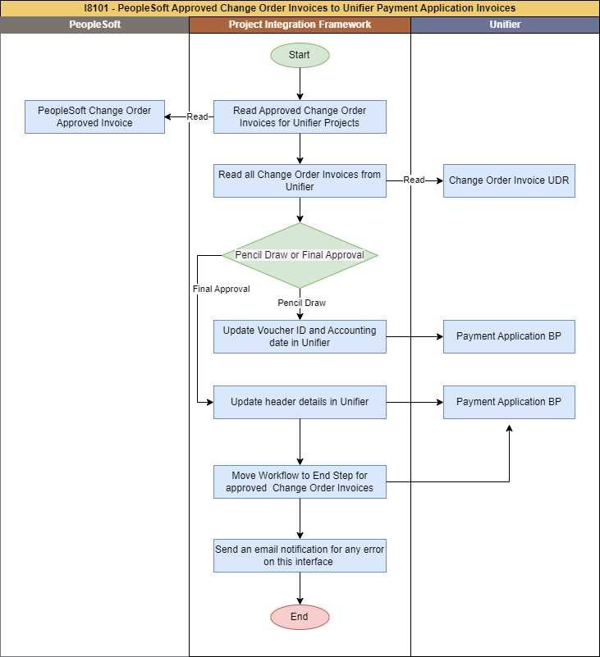
Figure 3: I8101 - PeopleSoft Approved Change Order Invoices to Unifier Payment Application Invoices

- Clear data in PIF tables (if any) from last interface run.
- PIF to extract Approved change order Invoice data for all Projects from PeopleSoft based on PIF last Run Date.
- PIF to update Voucher ID and Accounting date in Unifier when the record is in Pencil Draw status. When voucher is first pushed "PENCIL_DRAW" status.
- PIF will update the payment application header details when the record is in Final_Voucher_Build status. This includes updating the header details if the same voucher is pushed again in the Final_Voucher_Build status.
- PIF will move the workflow to the final step for approved Change Order Invoice BP records in Unifier after updating the header details.
- PIF will update the field " Integration Status " in the Unifier Approved Invoices BP, setting it to "Sent from PeopleSoft”.
- PIF will generate email error notifications if there is any error while inserting data into Unifier.

Data Mapping
The below is the SharePoint link for data mapping for this interface.
Oracle-NM-PeopleSoft-Unifier-Invoices-Integration-Mapping.xlsx ( PayApp Invoice Tab)

PIF Configuration
Interface Name: I8101 - PeopleSoft Approved Change Order Invoices to Unifier Payment Application Invoices

To be filled/corrected after completion of interface development.

Step No/ Intent | Step information | Business Rules / Comments
Step #: 10  Step Name: Truncate PIF table | Service Name: SQL Service  SQL Type: DELETE | Truncate all PIF tables, stage tables
Step #: 20  Step Name: Read Payment Application from PeopleSoft | Service Name: SQL Service  SQL Type: SELECT  PeopleSoft View Name: NM_UA_INV_034  Table Name: I8101_PS_PAYAPP | Read Payment Application from PeopleSoft
Step #: 30  Step Name: Skip if no data in PeopleSoft | Service Name: GoToService  Is Conditional: True  Go To Step Sequence: End Process (-1)  Table Name: I8101_PS_PAYAPP_ROWS | Check if there are any Payment Application records to process or not. If not Skip all the interface steps and move to end step.
Step #: 40  Step Name: Get Payment Application from Unifier | Service Name: UnifierRESTV2Service  Object Name: User Defined Report  Method Name: Get UDR  UDR Name: I8101_PAYAPPS  UDR Level: Company  Table Name: I8101_UNI_PAYAPP | Get existing Payment Application from Unifier using UDR
Step #: 50  Step Name: Check Payment Application Exists in Unifier | Service Name: SQL Service  SQL Type: Update  Table Name: I8101_PS_PAYAPP_ROWS | Check whether the given Payment application exists in Unifier.
Step #: 60  Step Name: Update the pif status to update voucher id and payment details | Service Name: SQL Service  SQL Type: Update  Table Name: I8101_PS_PAYAPP_ROWS | Update the PIF status according to the record’s status in Unifier.
Step #: 70  Step Name: Update the Payment Application records for processing | Service Name: SQL Service  SQL Type: SELECT  Table Name: I8101_PS_PAYAPP_ROWS | Loop to process one record at a time.
Step #: 80  Step Name: Update the voucher id in the pencil draw status | Service Name: UnifierRESTV2Service  Object Name: Business Process  Method Name: Update BP Record  Business Process Name: Payment Application  Table Name: I8101_PS_PAYAPP_ROWS | Update Voucher ID and Accounting date in Unifier for Pencil Draw status.
Step #: 90  Step Name: Update the payment details in the Final_Voucher_Build status | Service Name: UnifierRESTV2Service  Object Name: Business Process  Method Name: Update BP Record  Business Process Name: Payment Application  Table Name: I8101_PS_PAYAPP_ROWS | Update Payment details in Unifier for Final_Voucher_Build status.
Step #: 100  Step Name: Move payment application workflow to End Step | Service Name: UnifierRESTV2Service  Object Name: Business Process  Method Name: Update BP Record  Business Process Name: Payment Application  Table Name: I8101_PS_PAYAPP_ROWS | Move the workflow to the end step for approved Change Order Invoices in Unifier after updating the header details when the record is in Final_Voucher_Build status.
Step #: 110  Step Name: Go to update step | Service Name: GoToService  Is Conditional: True  Go To Step Sequence: Update the Payment Application records for processing  Table Name: I8101_PS_PAYAPP_ROWS | Move to the loop step for processing the next record.
Step #: 120  Step Name: End Process, Skip to run "Notify Failures" when there are no failed records | Service Name: GoToService  Is Conditional: True  Go To Step Sequence: End Process (-1)  Table Name: I8101_PS_PAYAPP_ROWS | Check if there are any failed Payment Application records or not. If not Skip all the interface steps and move to end step.
Step #: 130  Step Name: Notify Payment Application Failures | Service Name: Email Service  Conditional Criteria: Attachment Has Records  Attachment File Name: Error Notification : I8101_Payment_Application  Table Name: I8101_PS_PAYAPP_ROWS | Send an attachment listing all rows which are failed

Error/Warning Handling
Error # | Rule Name | Rule Description
E-01 | Approved change Order Invoice Record workflow update failed | Email will be sent to admin for any failure

Assumptions
- All drop down field value should be match between Unifier and PeopleSoft application.
- The data mapping sheet is designed for the flow of data from one system to another, and if a field is not added, there will be no data flow.
- PIF jobs are scheduled daily to run automatically, and they can also be run manually on demand by the administrator user.
- Invoices with Approved/Posted Vouchers will be sent to Unifier from Peoplesoft

Appendix A: Acronyms
Acronyms | Description
IB | Inbound
PIF | Project Integration Framework
OB | Outbound
WS | Web Services
RS | REST Services
UDR | User Defined Report
Figure 36: Acronyms

Appendix B: Issue Log
This Issue Log captures design changes made after sign-off of the use case requirements document.

Issue # | Description | Status | Date Open | Date Closed | Resolution | Comments
Figure 37: Issue Log

